 |  | Bath Community School / March Edition
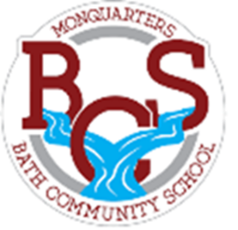
Monquarter Memo
Phone: 278-6000 Twitter: @BathMonquarters
Website: http://BCS.nbed.nb.ca/
Upcoming: March is Canadian Agricultural Literacy Month!
Friday, March 19th  No school for students  (Professional Learning day for staff)  Saturday, March 20th  Spring ahead – clocks go ahead 1 hour!  Thursday, March 25th  Grade 7 and 8 Field trip snowshoeing and bowling  Wednesday, March 31st  Report Cards go home  Grade 7 & 8 Field trip skiing at Crabbe Mountain  Friday, April 2nd  Good Friday – no school  Monday, April 5th  Easter Monday – no school  Wednesday, April 14th  No school for students  (Parent teacher & professional learning day for staff) |  |  |  |  | 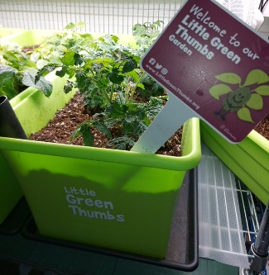  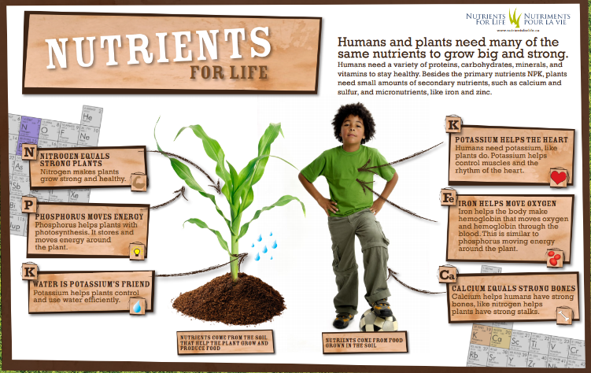  Many of our classrooms have vegetables and flowers growing!  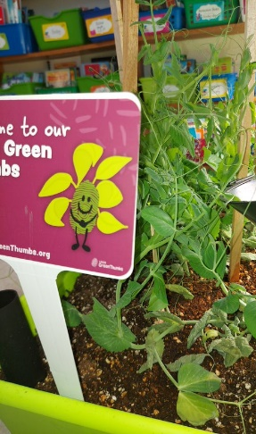  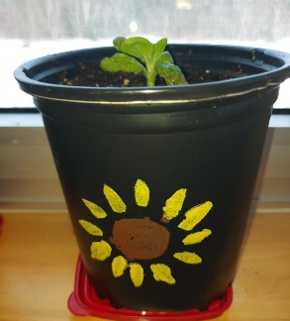
Reminder
Students need:
- two clean masks every day
- a clean water bottle
- warm, dry clothes for outdoor recess and/or Phys. Ed

